Profile of top 10 prestigious journals that published my papers

PLoS ONE
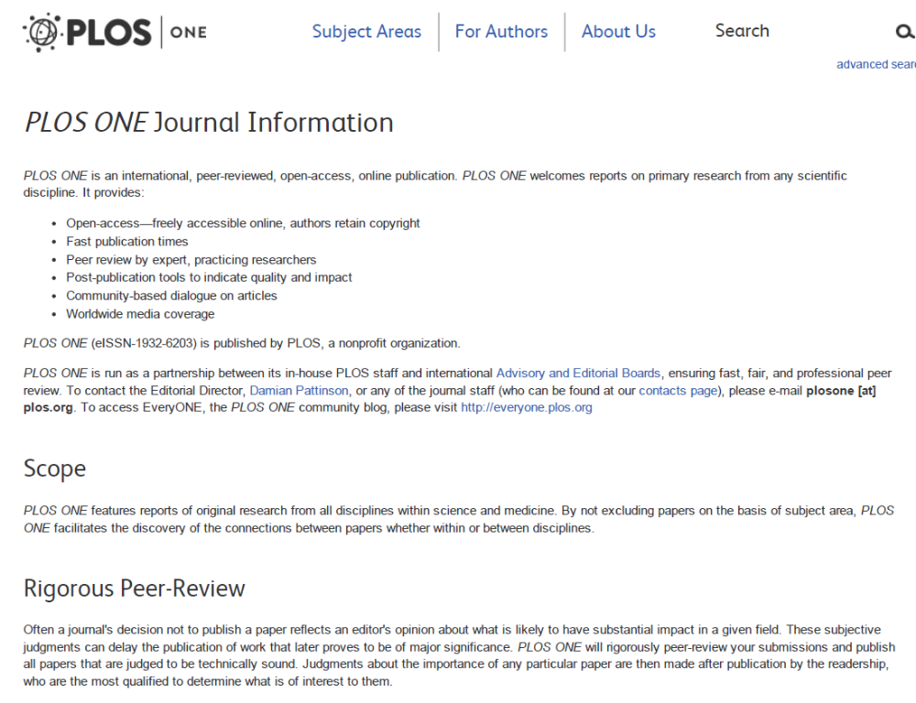
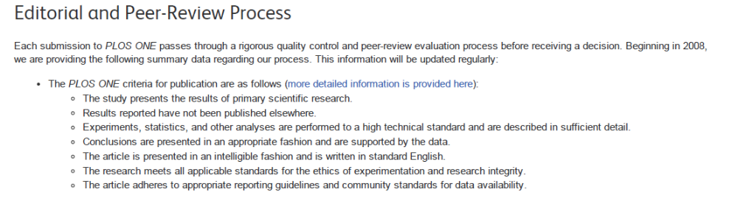

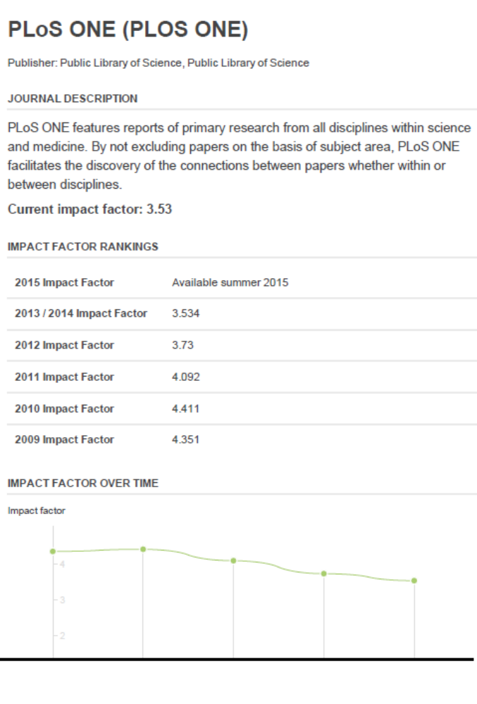ADDITIONAL DETAILS
5-year impact | 4.24
Cited half-life | 2.40
Immediacy index | 0.41
Eigenfactor | 0.78
Article influence | 1.55
Website | PLos One website
Other titles | PloS one, Public Library of Science one, PLoS 1
ISSN | 1932-6203
OCLC | 70662135
Material type | Document, Periodical, Internet resource
Document type | Internet Resource, Computer File, Journal / Magazine / Newspaper
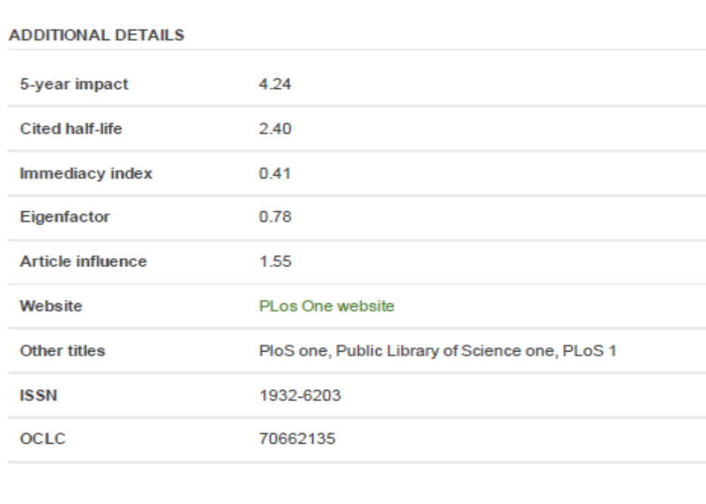
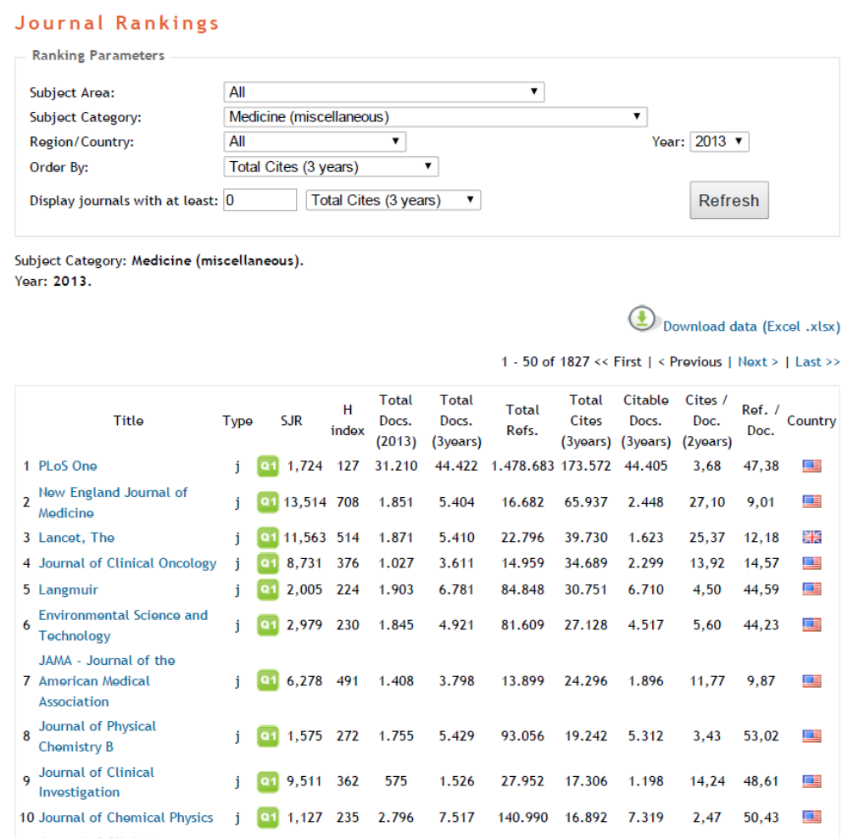
Journal of Affective Disorders
